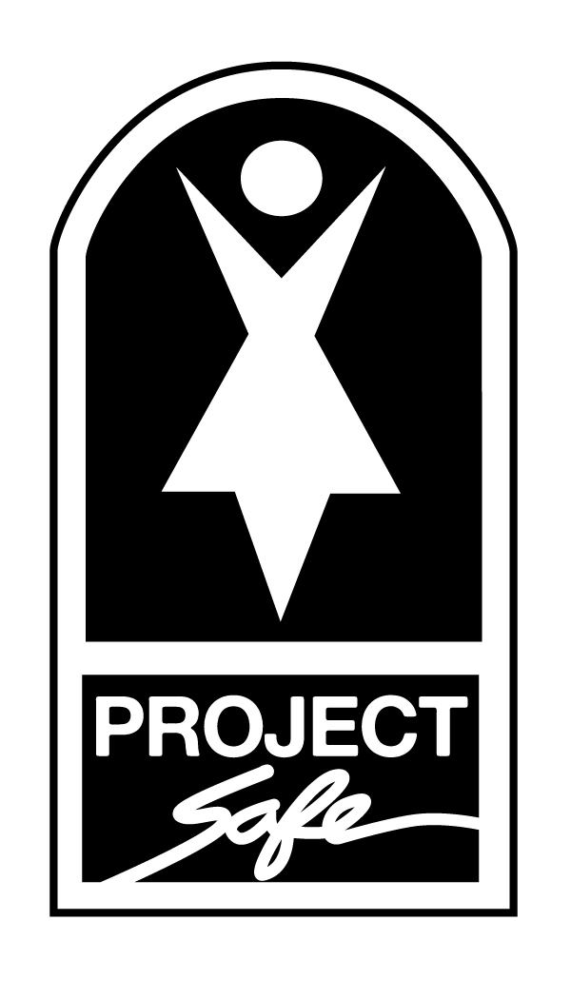

CONSTANT SHELTER SUPPLY NEEDS
UPDATED 7/.28/.14

Kitchen Supplies: Toiletries: For Children:
Cooking Oil Paper Towels Learning Toys
Coffee Hairspray Diapers (all sizes)
Plastic Wrap Hair Brushes Boys’ and Girls’ Pajama Sets
Ziploc Bags Hair Relaxer Kits (Regular) Similac - Sensitive Formula
Sugar Lotion Baby Wipes
Aluminum Foil Face Wash Boys’ and Girls’ Slippers
Coffee Filters Toilet Paper Baby Food

Cleaning Supplies:ggggg
Trash Bags Disinfectant Spray Powder Laundry Detergent Mops/ Buckets & Pinesol Dishwasher Powder (Cascade) Rubber Gloves Brooms/ Dustpans Dryer Sheets Sponges Clorox Wipes Toilet Bowl Brushes & Cleaner Ajax

Medicine/Medical Supplies:
EXCEDRIN migraine EXCEDRIN Back & Body Baby Laxative Adult Cold & Fever EQUATE Cold & Allergy Children’s PEPTO Junior Strength MOTRIN Lice Treatment Kits Children’s Fever Med Hand Sanitizer Antacid Tablets Vitamins
Antibiotic Ointment Bandaids Topical Benadryl Cream

Miscellaneous Supplies:
Sharpie Permanent Markers Pillowcases & Pillows Women’s Bras (Size B, C, D, DD)
Masking and Scotch Tape Twin Size Bedsheets Pots and Pans
Grocery and Gas Gift Cards Journals Umbrellas
Pajama Sets – all sizes Robes Bath and Hand Towels
Prepaid Minutes for Cell Phones Calculators Flashlights
Women’s Socks USB Jump Drives Women’s Underwear (Size 8-20)

Project Safe is a 501(c)3 corporation, and all contributions are tax deductible as allowed by law.
Project Safe strives to be a good steward of donated resources as well as of the environment, and recycles at all of our facilities.

